###--- Setup; load packages and read data ---###

library(readxl)
library(ggplot2)
library(dplyr)
library(forecast)
library(tseries) # For Jarque-Bera test

quakes<- read_xlsx('earthquakes.xlsx', col_names = FALSE)
colnames(quakes) <- c('year', 'nr_quakes')
# create lagged first difference; will be used later
quakes$lag_difference <- lag(quakes$nr_quakes, n = 1) - lag(quakes$nr_quakes, n = 2)

###--- Some preliminary analysis ---###

# Some visualization
ggplot(quakes, aes(x = year, y = nr_quakes)) + geom_line(col = 'blue', size = 1) +
xlab('Year') + ylab('Number of earthquakes') + ggtitle('Number of earthquakes 1900-2005') +
theme(axis.text=element_text(size=11),
axis.title=element_text(size=12),
plot.title = element_text(hjust = 0.5, size = 13, face = 'bold'))

# Create estimation/train sample 1900-1980
estimation <- filter(quakes, year <= 1980)

# Some visualization
ggplot(estimation, aes(x = year, y = nr_quakes)) + geom_line(col = 'blue', size = 1) +
xlab('Year') + ylab('Number of earthquakes') +
ggtitle('Number of earthquakes 1900-1980; estimation sample') +
theme(axis.text=element_text(size=11),
axis.title=element_text(size=12),
plot.title = element_text(hjust = 0.5, size = 13, face = 'bold'))

# Create hold-out/test sample after 1980
hold_out <- filter(quakes, year > 1980)

# Some visualization
ggplot(hold_out, aes(x = year, y = nr_quakes)) + geom_line(col = 'blue', size = 1) +
xlab('Year') + ylab('Number of earthquakes') +
ggtitle('Number of earthquakes 1981-2005; hold-out sample') +
theme(axis.text=element_text(size=11),
axis.title=element_text(size=12),
plot.title = element_text(hjust = 0.5, size = 13, face = 'bold'))

max_lag = 12
# plot autocorrelation
acf_quakes <- acf(estimation$nr_quakes, lag.max = max_lag)
# plot partial autocorrelation
pacf_quakes <- pacf(estimation$nr_quakes, lag.max = max_lag)

quakes_stats <- data.frame(acf = acf_quakes$acf[-1], # remove first corelation
pacf = pacf_quakes$acf,
Q_stat = NA,
p_val = NA)

# Now compute p-values and Q-statistics
for (i in 1:max_lag) {
# Compute Q-statistic
corr_stats <- Box.test(estimation$nr_quakes, lag = i,
type = 'Ljung-Box')
quakes_stats$Q_stat[i] <- corr_stats$statistic
quakes_stats$p_val[i] <- corr_stats$p.value
}

###--- Start with the model-building process ---###

# Since the arima function does not compute p-values, we implement our
# own function that takes the output of the Arima function as input, and then
# computes the p-value and t-statistic.
compute_pval <- function(arima_res) {
t_stat <- arima_res$coef / diag(arima_res$var.coef^0.5)
pval <- 2*pt(-abs(t_stat), df = length(arima_res$residuals)-1)
list(pval = pval, t_statistic = t_stat)
}

# We start with a simple ar(1) model;
ar1 <- Arima(estimation$nr_quakes, order = c(1, 0, 0))

resid_ar1 <- data.frame(year = estimation$year,
residuals = ar1$residuals)

# plot the residuals for ar1 model
ggplot(resid_ar1, aes(x = year, y = residuals)) + geom_line(col = 'blue', size = 1) +
geom_hline(yintercept = -sqrt(ar1$sigma2), linetype = 2) +
geom_hline(yintercept = sqrt(ar1$sigma2), linetype = 2) +
xlab('Year') + ylab('Residuals') + ggtitle('Residuals estimation sample; AR(1) model') +
theme(axis.text=element_text(size=11),
axis.title=element_text(size=12),
plot.title = element_text(hjust = 0.5, size = 13, face = 'bold'))

fit_ar1 <- data.frame(year = estimation$year,
real = estimation$nr_quakes,
fit = ar1$fitted)

# lets plot the auto correlation functions:
acf(ar1$residuals)

# also plot a histogram of the residuals
ggplot(resid_ar1, aes(x = residuals)) + geom_histogram(col = 'skyblue', fill = 'skyblue', bins = 20)

# Now we test whether the residuals are normally distributed. Neither of the two tests
# reject the nul-hypothesis that the residuals follow a normal distribution). In other words, we # can assume that the residuals follow a normal distribution.
# First we test normality with the Jarque-Bera test
jarque_res <- jarque.bera.test(ar1$residuals)
# and then with the more familiar Shapiro-Wilk test
shapiro_test <- shapiro.test(ar1$residuals)

# We can also plot the fit of the estimation sample for the ar1 model.
ggplot(fit_ar1, aes(x = year)) +
geom_line(aes(y = fit), col = 'blue', size = 1) +
geom_line(aes(y = real), col = 'red', size = 1) +
xlab('Year') + ylab('Residuals') +
ggtitle('Fitted (blue) vs real (red) values estimation sample; AR(1) model') +
theme(axis.text=element_text(size=11),
axis.title=element_text(size=12),
plot.title = element_text(hjust = 0.5, size = 13, face = 'bold'))

# Now we try to improve the model by adding the lag of the first-difference: 'y_{t-1} - y_{t-2}'.
# Since this model cannot be constructed with the 'order = c(p, d, q)' argument, we pass the lag
# of the first difference as a variable/regressor.
ar_diff <- Arima(estimation$nr_quakes, order = c(1, 0, 0),
xreg = estimation$lag_difference)
compute_pval(ar_diff) # Lag_difference not significant

# Maybe we can improve the model by adding 2 moving average terms?
arma12 <- Arima(estimation$nr_quakes, order = c(1,0,2))
# get pvalue and t-statistic
compute_pval(arma12)

# Or maybe we can improve the model by adding a second lag of y
ar2 <- Arima(estimation$nr_quakes, order = c(2,0,0))
# get p-value and t-statistic for ar(2) model
compute_pval(ar2)

# Let's try an arma(1,1) model:
arma11 <- Arima(estimation$nr_quakes, order = c(1,0,1))
# get p-value and t-statistic for arma(1,1) model
compute_pval(arma11)

# now we can start making predictions. To start, we will do recursive
# 1-step ahead predictions. Note that the model is already trained. All
# we are doing, is fitting the model with the new data. The Arima() function
# does not re-train the model when you pass another model as an argument.
ar1_full <- Arima(quakes$nr_quakes, model = ar1)
# the coefficients should not change when we add new data.
identical(ar1_full$coef, ar1$coef) # Should evaluate to TRUE
# extract all 'fitted' values after 1980. This way of extracting works since in
# this case the fitted values in the ar1 model correspond to the observations in quakes.
pred_onestep <- ar1_full$fitted[quakes$year > 1980]

onestep_df <- data.frame(year = quakes$year,
real = quakes$nr_quakes,
predictions = c(rep(NA, nrow(estimation)), pred_onestep))
# plot the one step ahead predictions after 1980 with the real values and the historical
# number of earthquakes
ggplot(onestep_df, aes(x = year)) +
geom_line(aes(y = predictions), col = 'blue', size = 1) +
geom_line(aes(y = real), col = 'red', size = 1) +
geom_vline(xintercept = 1980, linetype = 2, size = 1) +
xlab('Year') + ylab('Number of Earthquakes') +
ggtitle('One step ahead predictions (blue) vs real (red) number of earthquakes; AR(1) model') +
theme(axis.text=element_text(size=11),
axis.title=element_text(size=12),
plot.title = element_text(hjust = 0.5, size = 13, face = 'bold'))

# Now we will add 95% confidence intervals to the previous plot. Note that the confidence interval is
# approximately given by the: predicted y +/- standarddev(y).
upper <- pred_onestep + 2*ar1$sigma2^0.5
lower <- pred_onestep - 2*ar1$sigma2^0.5
onestep_df$upper <- c(rep(NA, nrow(estimation)), upper)
onestep_df$lower <- c(rep(NA, nrow(estimation)), lower)

ggplot(onestep_df, aes(x = year)) +
geom_line(aes(y = predictions), col = 'blue', size = 1) +
geom_line(aes(y = real), col = 'red', size = 1) +
geom_line(aes(y = upper), size = 0.5, linetype = 2) +
geom_line(aes(y = lower), size = 0.5, linetype = 2) +
geom_vline(xintercept = 1980, linetype = 2, size = 1) +
geom_ribbon(aes(ymin = lower, ymax = upper), alpha = 0.2) +
xlab('Year') + ylab('Number of Earthquakes') +
ggtitle('One step ahead predictions (blue) vs real (red) number of earthquakes; AR(1) model') +
theme(axis.text=element_text(size=11),
axis.title=element_text(size=12),
plot.title = element_text(hjust = 0.5, size = 13, face = 'bold'))

# As a final exercise, we will now use the full earthquake time series to predict the
# number of earthquakes 15 years into the future.
# First, we re-train the ar1 model using the complete time series
ar1_new <- Arima(quakes$nr_quakes, order = c(1, 0, 0))
# forecast 15 years into the future
forecast_15yrs <- forecast(ar1_new, h = 15)

forecast_df <- data.frame(year = 1900:2020,
nr_quakes = c(quakes$nr_quakes, forecast_15yrs$mean),
upper = c(rep(NA, nrow(quakes)), forecast_15yrs$upper[, '95%']),
lower = c(rep(NA, nrow(quakes)), forecast_15yrs$lower[, '95%']))

ggplot(forecast_df, aes(x = year)) +
geom_line(aes(y = nr_quakes), col = 'red', size = 1) +
geom_vline(xintercept = 2005, linetype = 2, size = 1) +
geom_line(aes(y = upper), size = 0.5, linetype = 2) +
geom_line(aes(y = lower), size = 0.5, linetype = 2) +
geom_ribbon(aes(ymin = lower, ymax = upper), alpha = 0.2) +
xlab('Year') + ylab('Number of Earthquakes') +
ggtitle('Forecast of the number of earthquakes after 2005 with 95% C.I.; AR(1) model') +
theme(axis.text=element_text(size=11),
axis.title=element_text(size=12),
plot.title = element_text(hjust = 0.5, size = 13, face = 'bold'))

Resultaten Grafiekjes

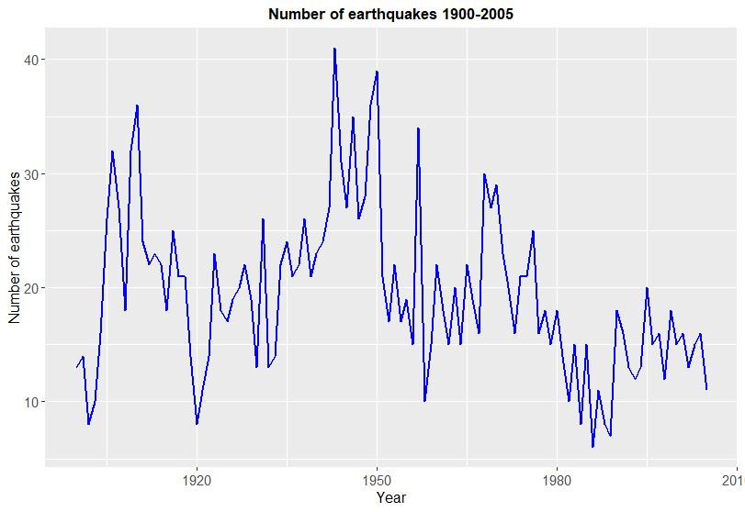
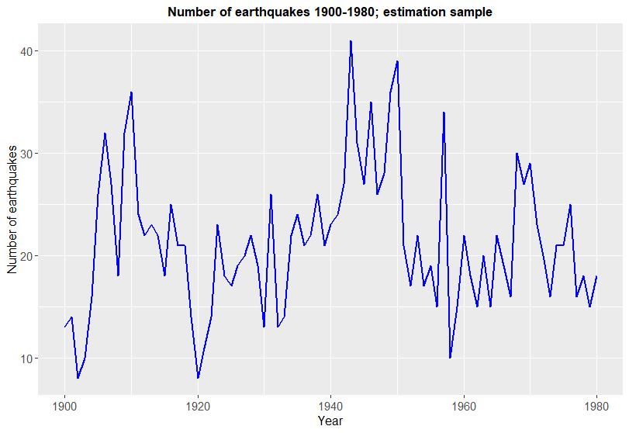
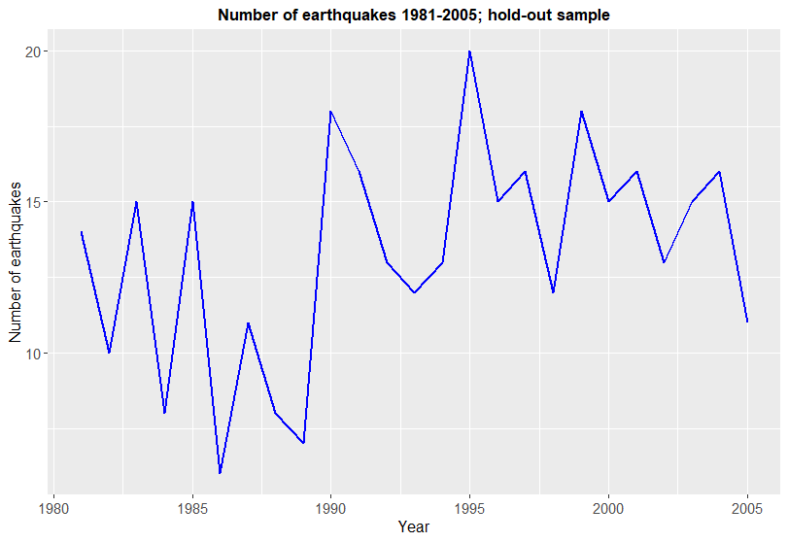
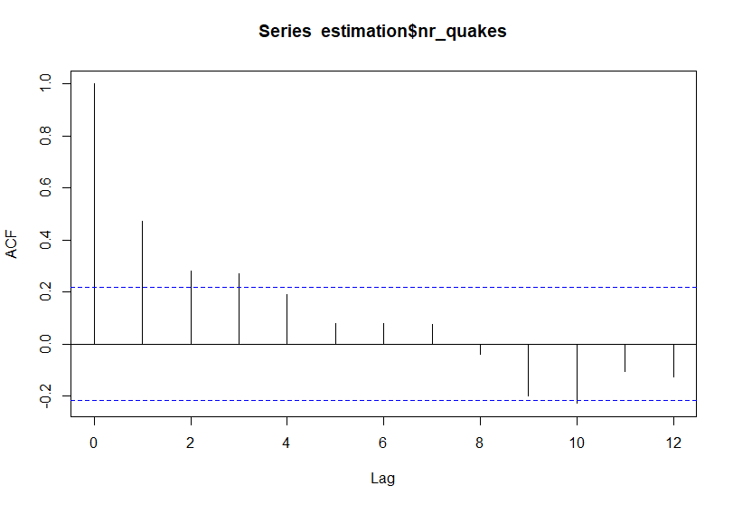
De auto correlatie functie voor de estimation sample.
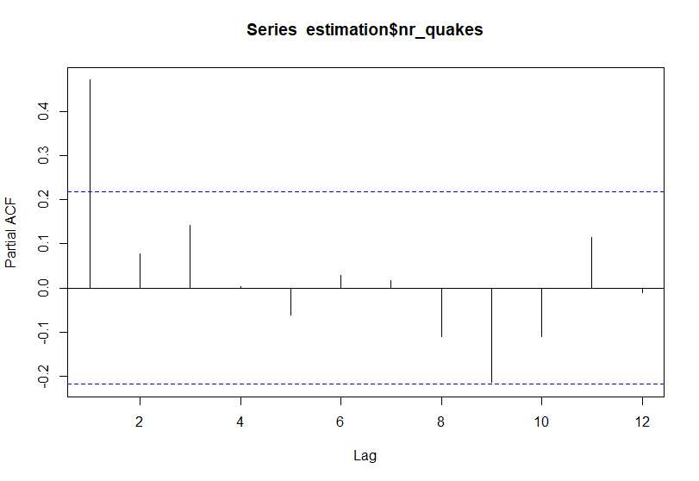

De partiele auto correlatie functie voor de estimation sample.
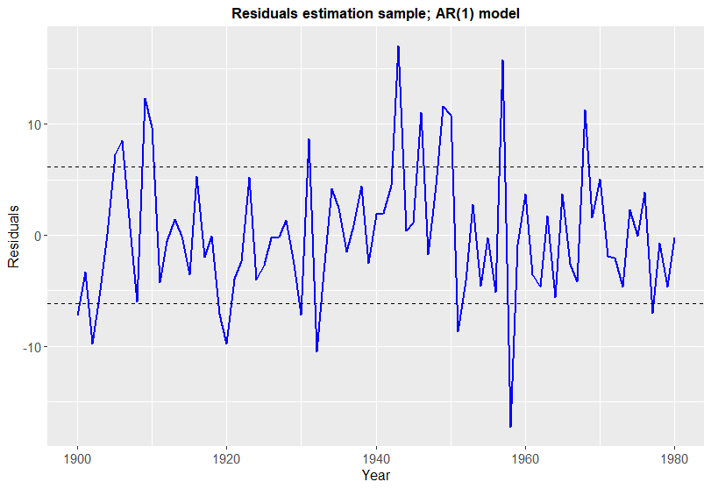
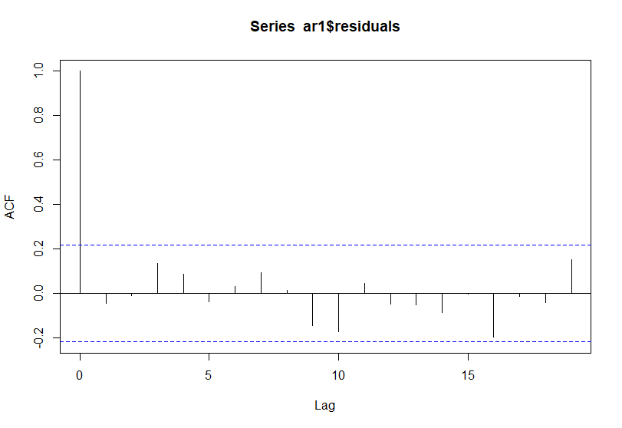

Autocorrelatie functie voor de residuals in het ar(1) model, gefit op de estimation sample.
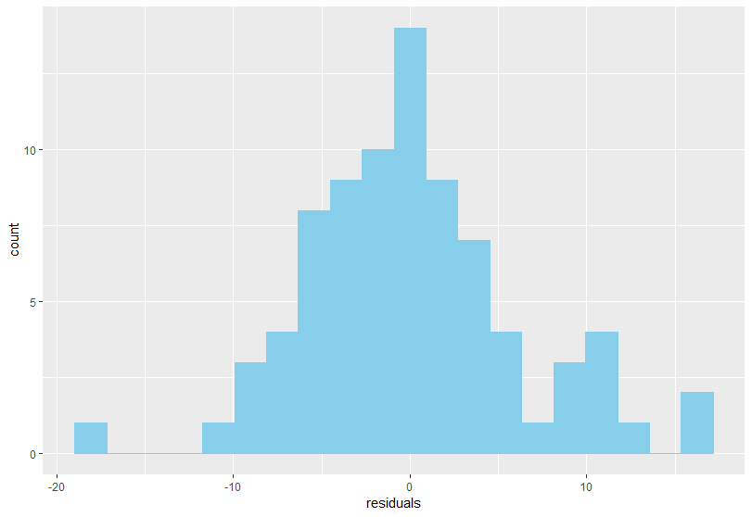
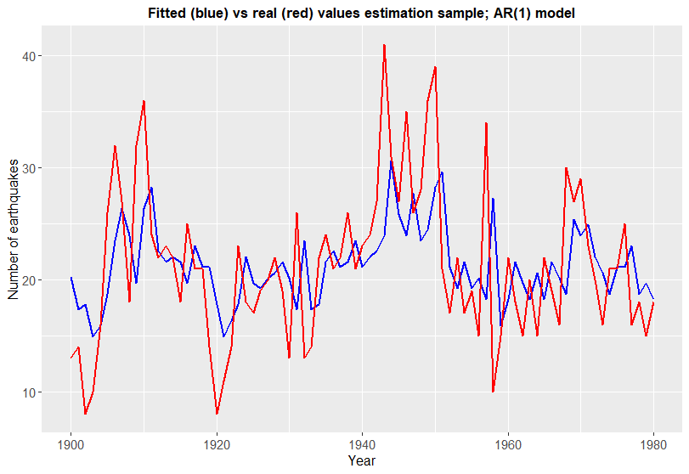
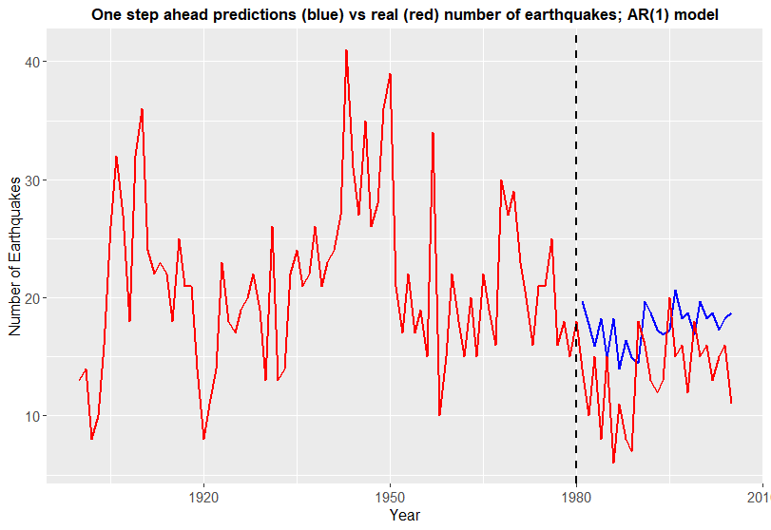
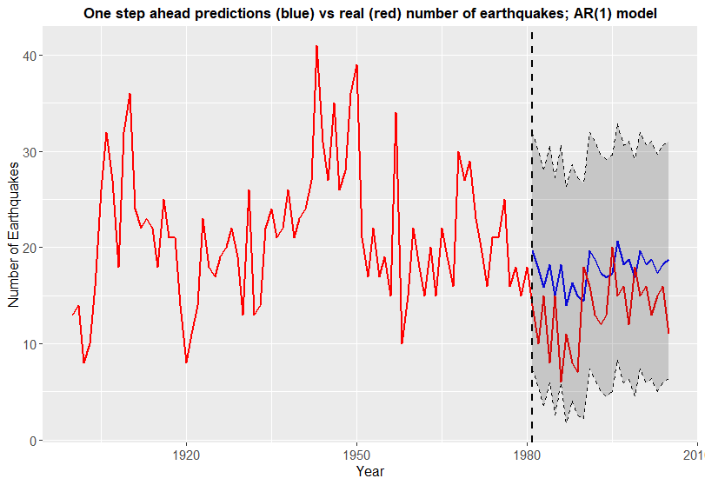
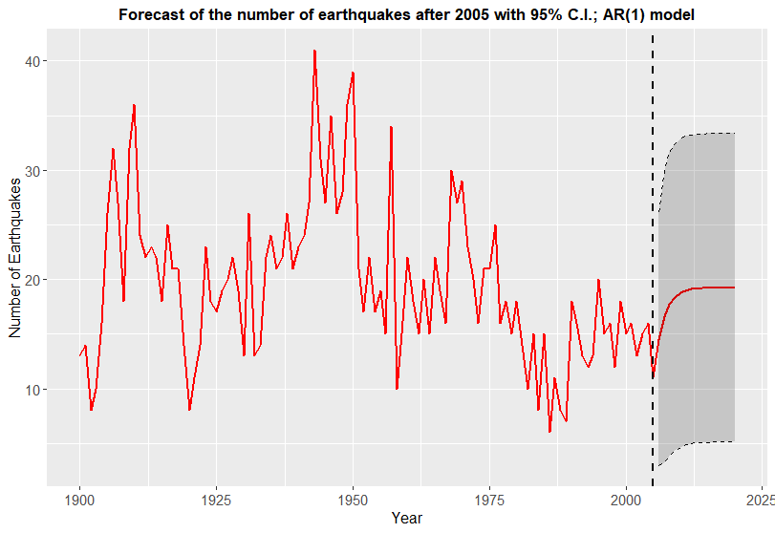

Coefficienten + SE’s Modellen:
AR(1):
ARIMA(1,0,0) with non-zero mean

Coefficients:
ar1 mean
0.4748 21.2059
s.e. 0.0978 1.2718

sigma^2 estimated as 37.83: log likelihood=-261.19
AIC=528.38 AICc=528.69 BIC=535.56

AR(1) met lagged difference:
Regression with ARIMA(1,0,0) errors

Coefficients:
ar1 intercept estimation$lag_difference
0.4658 21.3474 -0.0142
s.e. 0.1052 1.2782 0.0813

sigma^2 estimated as 37.99: log likelihood=-255.38
AIC=518.77 AICc=519.3 BIC=528.35

ARMA(1,2)
ARIMA(1,0,2) with non-zero mean

Coefficients:
ar1 ma1 ma2 mean
0.7767 -0.3469 -0.0919 20.9796
s.e. 0.1439 0.1807 0.1303 1.6484

sigma^2 estimated as 37.91: log likelihood=-260.27
AIC=530.54 AICc=531.34 BIC=542.51

AR(2)
ARIMA(2,0,0) with non-zero mean

Coefficients:
ar1 ar2 mean
0.4346 0.0864 21.1518
s.e. 0.1101 0.1112 1.3859

sigma^2 estimated as 38.02: log likelihood=-260.89
AIC=529.77 AICc=530.3 BIC=539.35

ARMA(1,1)
ARIMA(1,0,1) with non-zero mean

Coefficients:
ar1 ma1 mean
0.7260 -0.3365 21.0228
s.e. 0.1672 0.2311 1.5989

sigma^2 estimated as 37.66: log likelihood=-260.52
AIC=529.03 AICc=529.56 BIC=538.61

